# **“Project - Phase II: Decision Making**

Group Members: **Aathira Vazaiel Raghavan (1233857497),**

**Adhithi Sathish Kumar (1233343815),**

**Ishwariya Pandi (1233885850),**

**Vaishmitha Reddy Biyyapu (1233298757)**

**IFT 533: Data Visualization & Reporting for IT**

**PROF. ASMAA ELBADRAWY**

APRIL 27, 2025”

**DECISION MAKING: THE SECOND STEP**

**“Section 1: Used Visualization Tools “**

### CHOOSING VISUALIZATION TOOLS

For this project, the following visualization tools have been selected:

**1. Dashboard Actions (Tableau)**

Interactivity: Dashboard Actions enable interactivity with dashboard elements, i.e., filtering or highlighting charts based on user clicks.

User-Driven Exploration: Enables additional data exploration without cluttering the dashboard.

Enhanced Storytelling: Guides users visually through different layers of insights, increasing engagement and informativeness.

**2. Tableau Prep Builder**

Data Preparation: Tableau Prep Builder is ideal for cleaning, reshaping, and preparing data sets for visualization.

Efficiency: Speeds up the process of data cleaning compared to manual cleaning using Excel or SQL.

Integration: Integrates well with Tableau Desktop, enabling a seamless workflow from data prep to visualization.

**3. Table Calculations (Tableau)**

Advanced Metrics: Enables running totals, rankings, percentages, and dynamic calculations within Tableau.

Flexibility: Allows calculation to be customized based on user interactions and decisions.

Customization: Allows the creation of KPIs and dynamic metrics such as average risk scores or trend analysis.

### “Section 2: Explanation of Required Data Pre-processing”

### DATA PREPARATION & PREPROCESSING

**Handling Missing Values**

Upon examining the Cleveland Heart Disease dataset, we discovered that several variables, such as thal (thalassemia status) and ca (number of major vessels), had missing entries denoted by "?" We started by replacing all "?" entries with NaN values to guarantee the accuracy of our visualizations. Then, depending on the attribute's nature, we either eliminated the rows that corresponded to these missing values or imputated the missing entries using the most frequent (mode) value.

**Data Type Correction**

We fixed the missing values and then fixed all of the characteristics' data types. For instance, ca and thal were changed to the proper numerical types (float or integer) after being first regarded as strings because of the missing values. For Mural and Tableau to build visualizations smoothly, it was crucial to make sure that all fields had the appropriate data types, including ratio attributes like age, chol, and thalach and categorical attributes like sex, cp, and exang.

**Attribute Engineering**

We changed the target attribute to improve the clarity of our visualizations. Target initially used a scale to identify the severity of heart disease, but we streamlined it into two categories:

• 0 for no heart disease,

• 1 for presence of heart disease (if original target value > 0).

We also made the decision to translate numerical categories into labels that are understandable by humans for attributes like:

• cp (Chest Pain Type),

• slope (Slope of ST Segment),

• thal (Thalassemia Type).

For users who might not be familiar with the encoded values, this step helps to make the dashboards more user-friendly and clear.

**Normalization (If Required)**

We talked about normalizing these characteristics to a 0–1 range if necessary for particular visualizations like heatmaps or cluster analysis because our dataset contains ratio-level variables like age, chol, trestbps, and thalach. This guarantees that each feature contributes equally when needed and that variables with wider ranges do not take center stage in the investigation.

**Consistency Check**

We carried out a last consistency check prior to beginning the visualization stage to ensure that:

• There were no missing values left,

• All data types matched their expected roles (e.g., categorical, ordinal, ratio),

• Attribute meanings matched those identified in our mural dashboard, such as distinguishing between ordinal and categorical data types.

By following these preparatory procedures, we made sure that our dataset was clear, consistent, and prepared for creating informative and approachable Tableau and Mural visualizations.

**“Section 3: List of Final Sets of Questions”**

### LIST OF THE FINAL SET OF QUESTIONS

### 1. What is the age distribution of patients diagnosed with heart disease compared to those without?

### 2. How does heart disease prevalence differ between male and female patients?

### 3. What are the most common chest pain types among patients with and without heart disease?

### 4. How many patients in the dataset are diagnosed with heart disease, and how many are not?

### 5. What is the gender distribution of all patients in the dataset?

### 6. What is the average maximum heart rate for patients with heart disease compared to those without?

### 7. Which thalassemia types are most frequently observed among patients with heart disease?

### 8. How many patients with fasting blood sugar greater than 120 mg/dL have heart disease compared to those who do not?

### 9. What is the distribution of resting blood pressure among patients with and without heart disease?

### 10. How does the number of major vessels colored by fluoroscopy vary between patients with and without heart disease?

**“Section 4: Dashboard Plot Drafts”**

### LIST OF PLOTS

We meticulously chose suitable plots based on the characteristics of the dataset and the kind of analysis needed in order to methodically answer each of the research questions. The plots that follow are intended to offer interactive, perceptive, and understandable visualizations that complement the project's objectives.

**Plot 1: Age Distribution by Heart Disease Status**

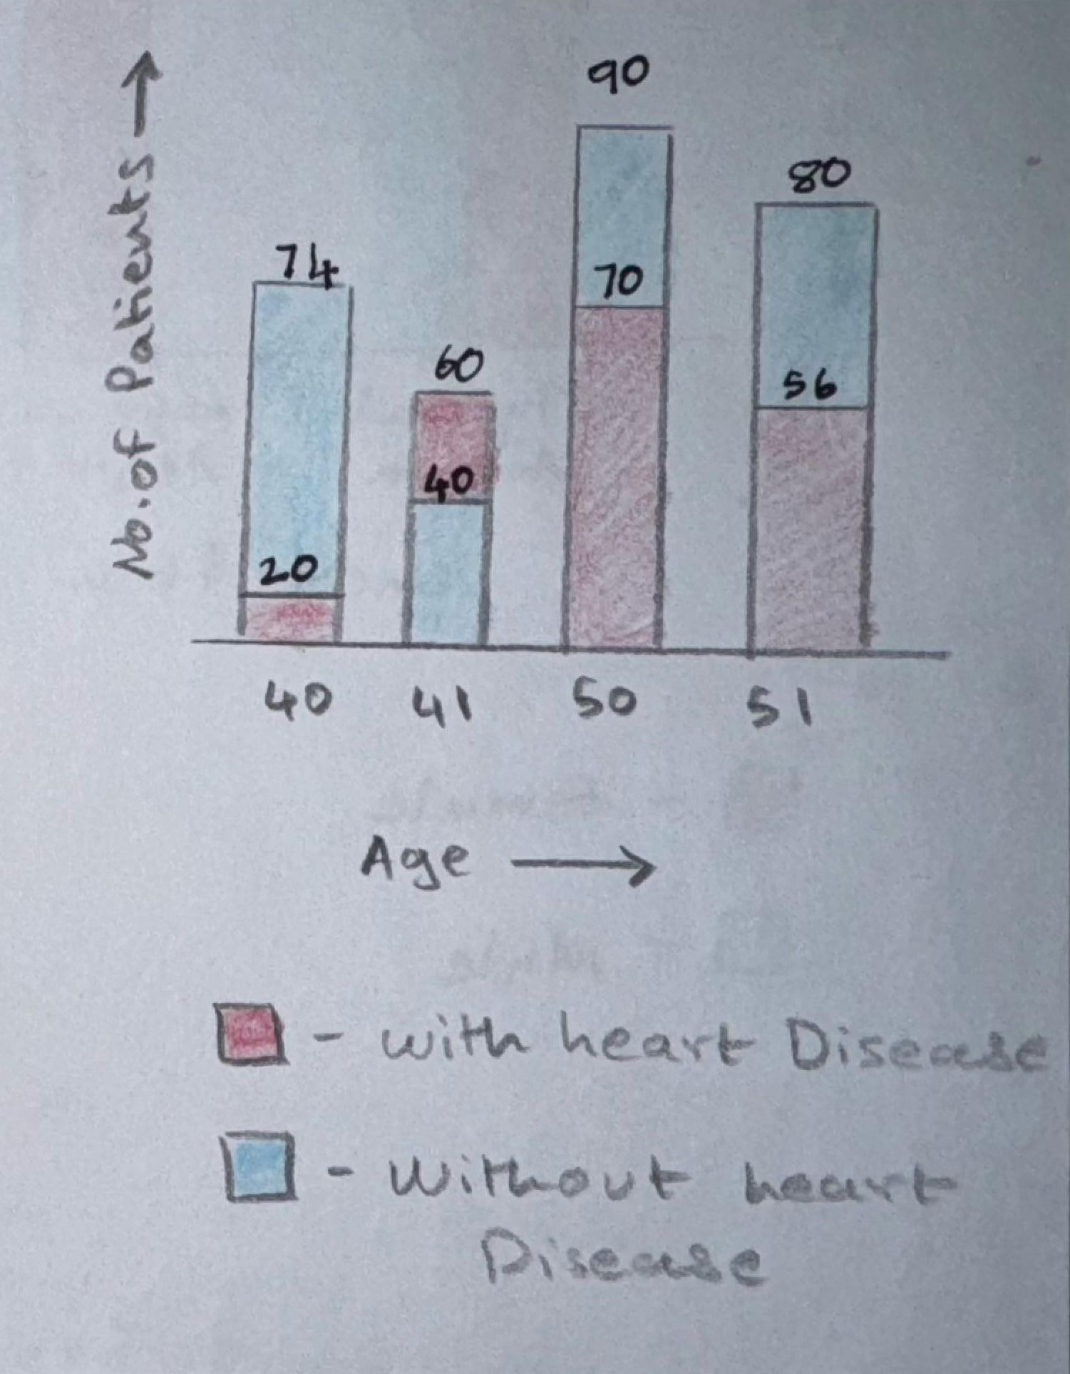

The age distribution of patients with and without cardiac disease will be displayed using a overlapping histogram. In order to answer Question 1, this figure will illustrate the differences in age between the two groups. color will be used as a pre-attentive trait, with blue being used for patients without heart disease and red for those who do. The height of the bars will show the frequency, and the position along the X-axis will show the various age buckets. The overlapping effect will draw attention to group differences.

**Plot 2: Heart Disease Prevalence by Gender**

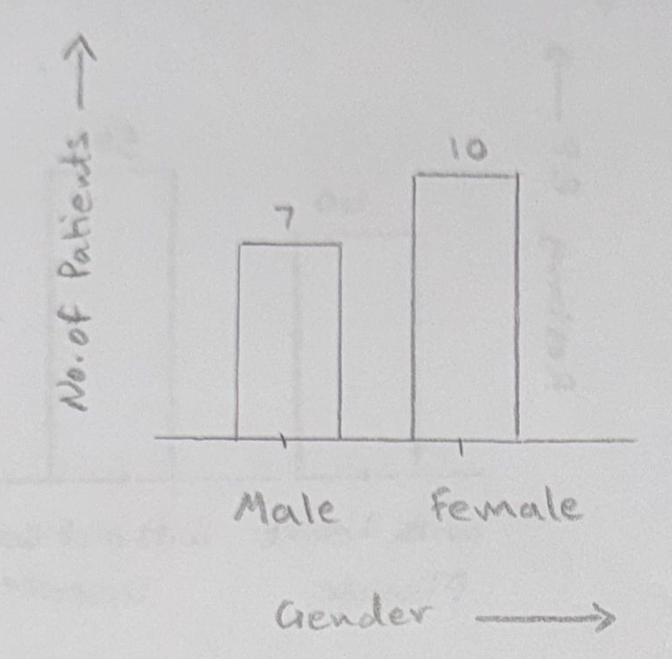

To illustrate the prevalence of heart disease among male and female patients for Question 2, we will construct a stacked bar chart. The length of the stacked bars will show the total number of patients, while the color will indicate the status of heart disease (blue for no disease, red for disease). On the X-axis, gender categories will be arranged in alphabetical order (Male, Female).

**Plot 3: Chest Pain Type Distribution**

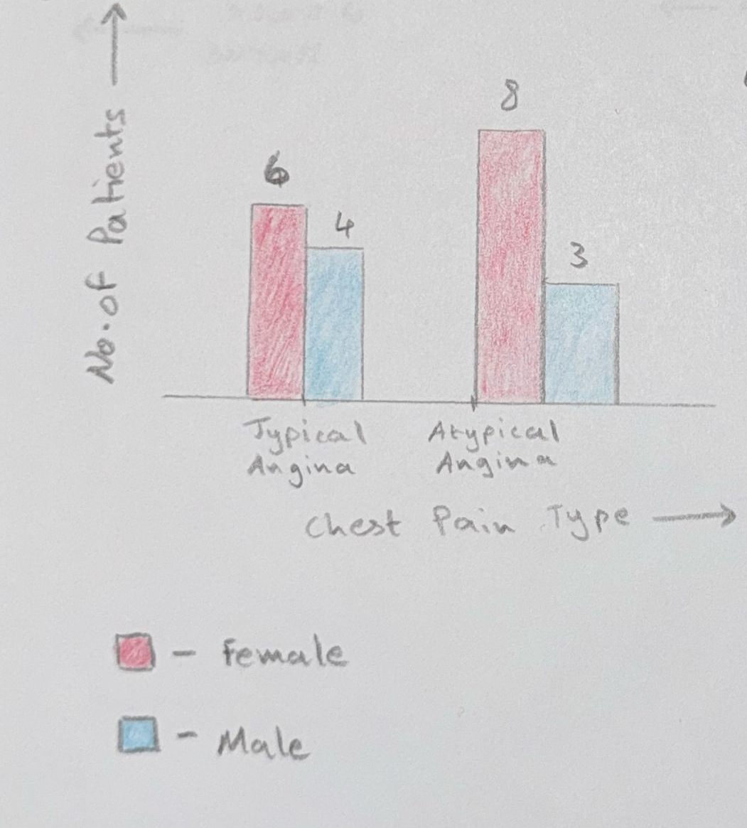

A grouped bar chart will be used to illustrate the distribution of various chest pain types (cp) among patients with and without heart disease in order to respond to Question 3. Each type of chest discomfort will be represented by a different color, and the bars will be grouped by disease status. Starting with the most prevalent variety, the different types of chest discomfort will be arranged by frequency.

**Plot 4: Overall Heart Disease Diagnosis Count**

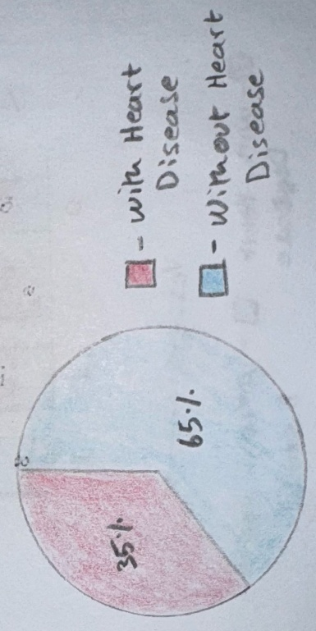

The proportion of patients diagnosed with and without heart disease will be displayed in a simple pie chart for Question 4. Slice size will show proportions, and color will show whether heart disease is present (red) or not (blue). There won't be any need for extra interaction because this is a simple distribution overview.

**Plot 5: Gender Distribution of Patients**

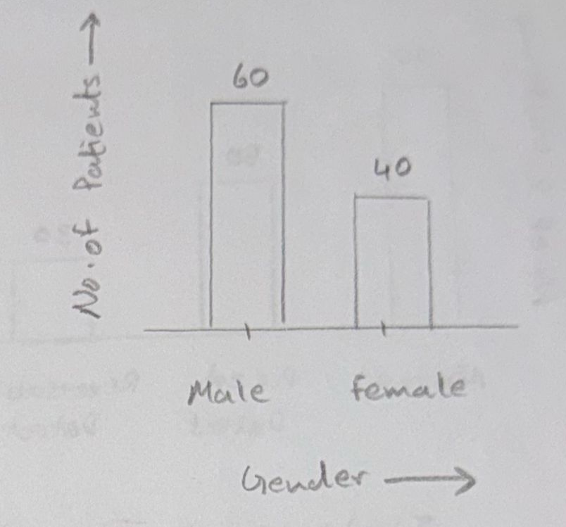

We will create a bar chart that shows the gender distribution of every patient in the dataset in order to respond to Question 5. The total count for each gender, arranged in alphabetical order, will be represented by the height of each bar.

**Plot 6: Average Maximum Heart Rate Comparison**

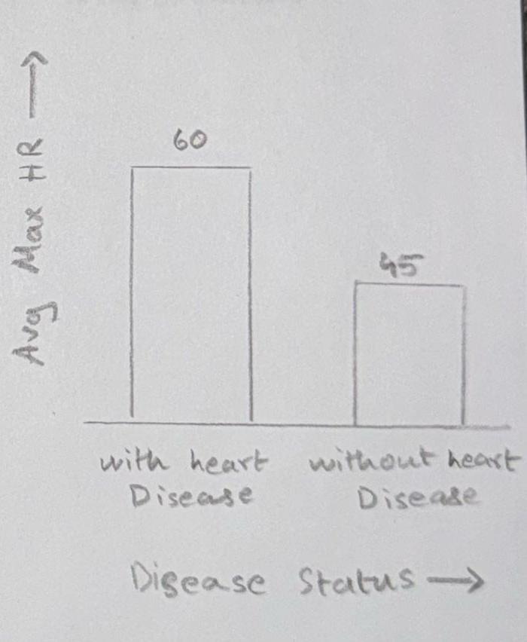

In order to compare the average maximum heart rate (thalach) between patients with and without heart disease, a side-by-side bar chart will be created for Question 6. The height of the bars will show the average values. This will make it simple to compare the two groups visually.

**Plot 7: Thalassemia Type Frequency**

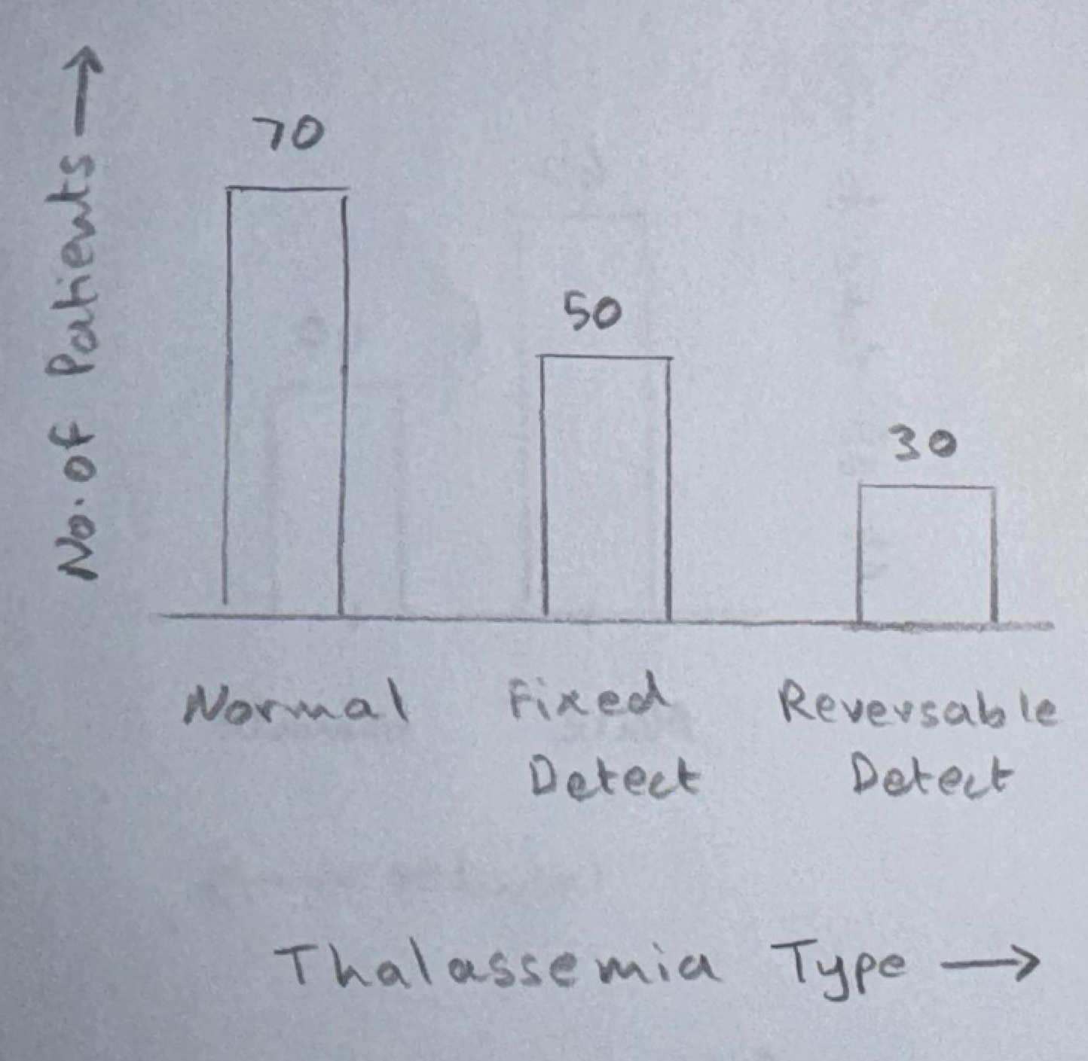

The frequency of thalassemia types (thal) among patients with heart disease will be displayed in a bar chart in order to answer Question 7. To highlight the most prevalent varieties first, the bars will be ordered by frequency in descending order.

**Plot 8: Fasting Blood Sugar vs Heart Disease**

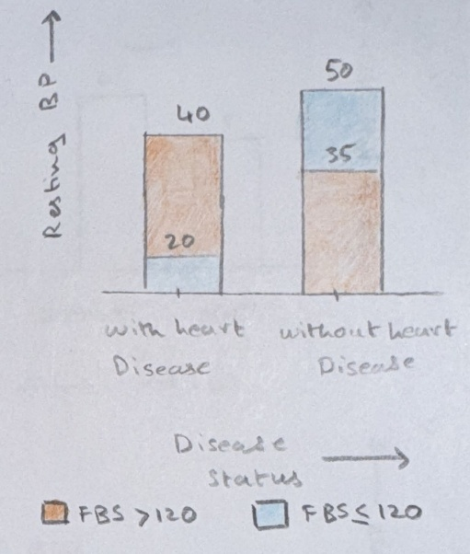

To compare patients with fasting blood sugar levels above 120 mg/dL and those with lower levels across heart disease status, a Stacked bar chart will be utilized for Question 8. FBS >120 (orange) and FBS ≤120 (blue) will be distinguished by Color, and comparisons within each disease status group will be displayed by the grouped position.

**Plot 9: Resting Blood Pressure Distribution**

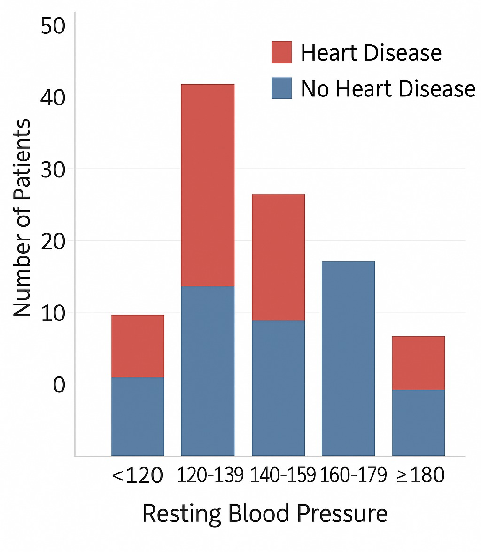

The distribution of resting blood pressure (trestbps) between patients with and without heart disease will be visualized using a box plot in order to respond to Question 9. Users will be better able to comprehend the dispersion and median values between groups thanks to the color (blue for no disease, red for disease) and positioning of the boxplot elements (median, quartiles).

**Plot 10: Major Vessels Colored by Fluoroscopy**

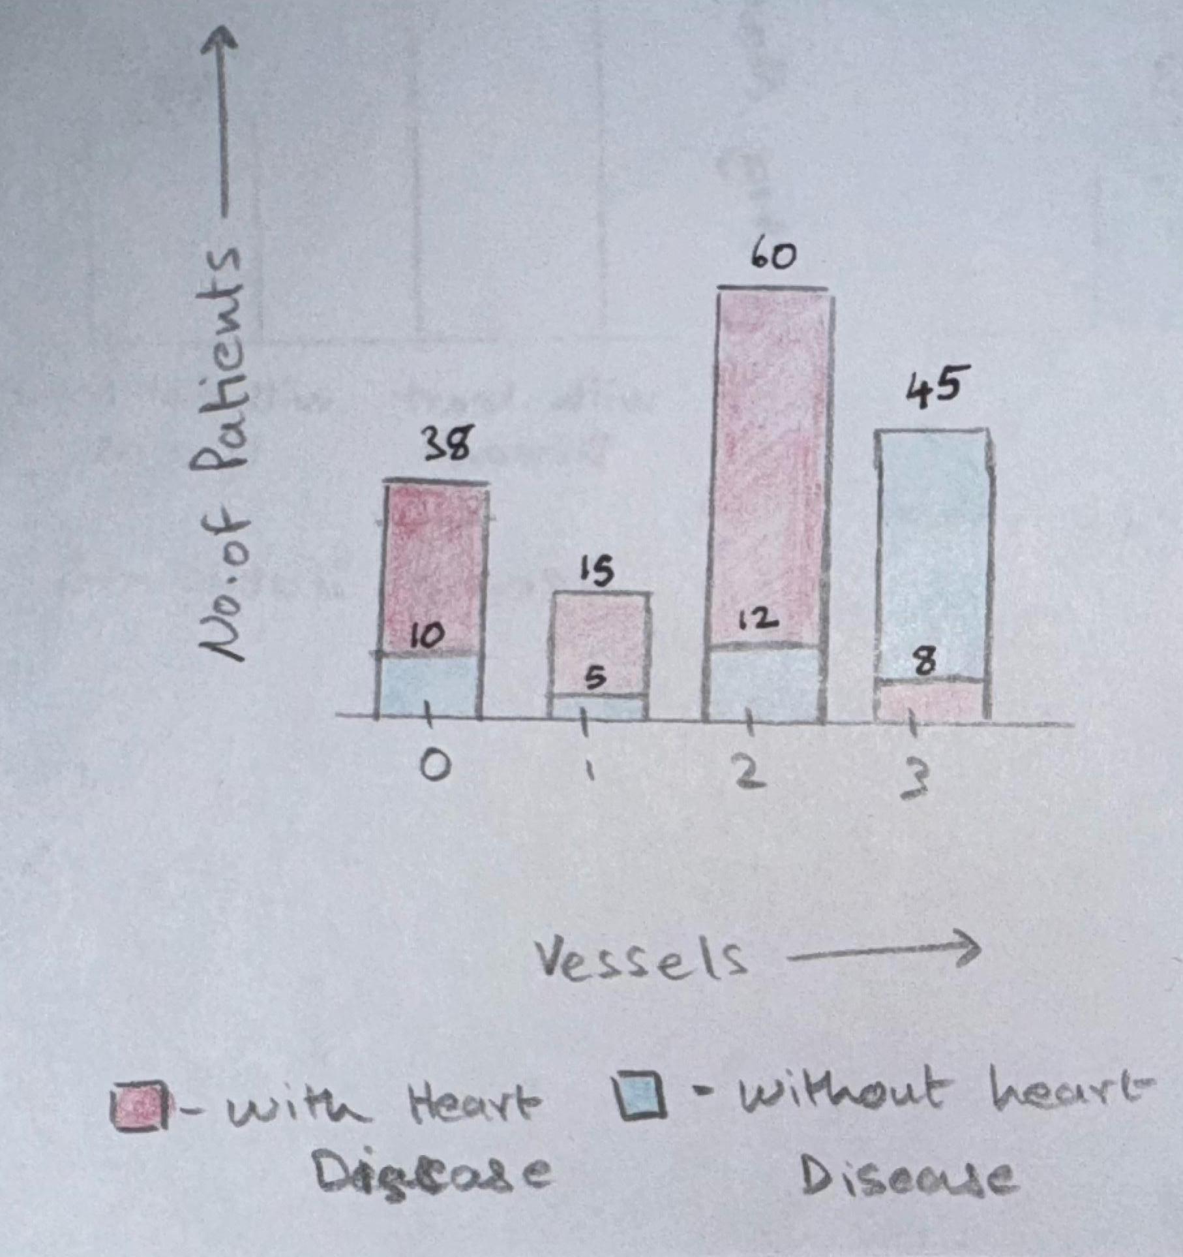

The number of main vessels ({ca`) colored by fluoroscopy in patients with and without heart disease will be shown in a grouped bar chart for Question 10. The bars will be arranged numerically according to the number of vessels (0, 1, 2, 3), and grouped by illness status and the color blue is used to show no heart disease, red for with heart disease. To improve distinction, vessel counts will be represented by different colors.

### “Section 5: Dashboard Interactivity”

### LIST OF INTERACTIVE CONTROLS

## **Control 1: Heart Disease Status (Single-Value List)**

Users can filter the dashboard by heart disease status with this control.  
It will be used to choose whether data for patients with or without cardiac disease is displayed in the plots.

* **Plots connected:**
  + Plot 1: Age Distribution by Heart Disease Status
  + Plot 3: Chest Pain Type Distribution
  + Plot 7: Thalassemia Type Frequency
  + Plot 10: Major Vessels Colored by Fluoroscopy
* **Value Range:**  
  Heart Disease and No Heart Disease are the control values, which are taken from the dataset's target property.
* **Type of Control:**  
  Single-value list (radio buttons).

## **Control 2: Gender Filter (Drop-down)**

Users can filter the visualizations by gender (Male, Female, or All) with this option.  
It gives you the freedom to examine gender-specific trends.

* **Plots connected:**
  + Plot 2: Heart Disease Prevalence by Gender
  + Plot 5: Gender Distribution of Patients
  + Plot 6: Average Maximum Heart Rate Comparison
  + Plot 8: Fasting Blood Sugar vs Heart Disease
  + Plot 9: Resting Blood Pressure Distribution
* **Value Range:**  
  The control values are Male, Female, and All, loaded from the sex attribute in the dataset.
* **Type of Control:**   
  Drop-down menu.

## **Control 3: Age Group Filter (Multi-select Drop-down)**

This control allows users to filter patients by age buckets (e.g., 30-40 years, 40-50 years, etc.).  
This gives users the ability to explore trends across different age groups.

* **Plots connected:**
  + Plot 6: Average Maximum Heart Rate Comparison
  + Plot 8: Fasting Blood Sugar vs Heart Disease
* **Value Range:**  
  The control values are pre-defined age buckets, which are not directly available in the dataset but are created by binning the age attribute.
* **Type of Control:**  
  Multi-select drop-down.

## **Control 4: Fasting Blood Sugar Group (Drop-down)**

This control allows users to compare patients based on their fasting blood sugar levels (greater than 120 mg/dL or not).  
It helps analyze how fasting blood sugar correlates with heart disease.

* **Plots connected:**
  + Plot 8: Fasting Blood Sugar vs Heart Disease
* **Value Range:**  
  The control values are FBS >120 mg/dL and FBS ≤120 mg/dL, loaded from the fbs attribute in the dataset.
* **Type of Control:**  
  Drop-down menu.

## **Static Visualizations (No Controls)**

Some plots are intended to remain static because their insights are independent of filtering:

* Plot 4: Heart Disease Diagnosis Count (Pie Chart)
* Plot 5: Gender Distribution (Bar Chart or Pie Chart)

Unless they are optionally connected to filters for heart disease or gender, these visualizations don't need any interactive controls.

**“Section6:”**

**“Reference:”**

1. Dataset link:

<https://archive.ics.uci.edu/dataset/45/heart+disease>

2. Mural Link: <https://app.mural.co/t/groupproject4860/m/groupproject4860/1744922611269/3c819384f9cf616b64334fd813ba36b991207e95>

Bottom of Form